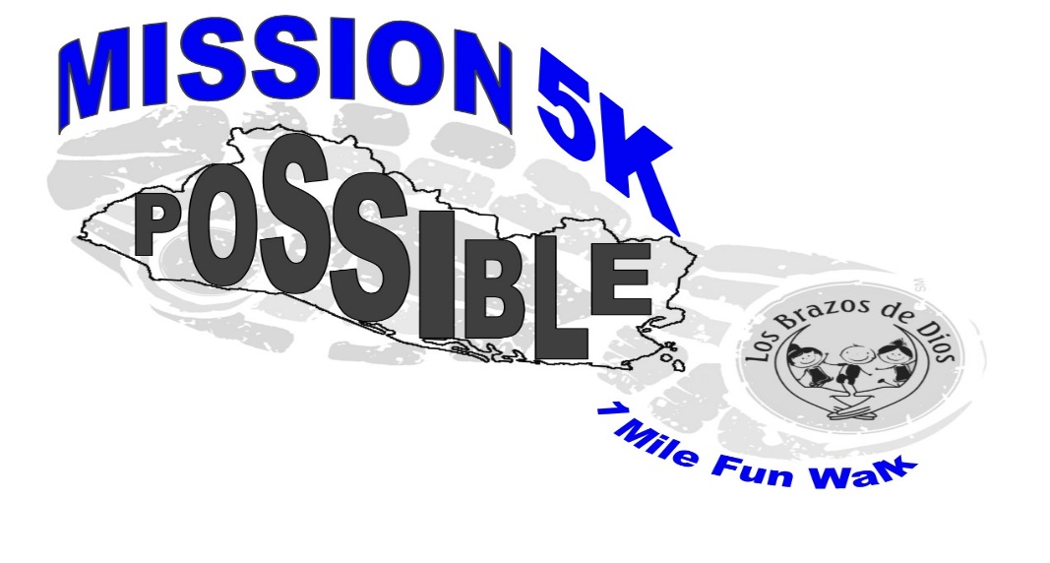 AGE DIVISIONS
11 & under
12-14 45-49
15-19 50-54
20-24 55-59
25-29 60-64
30-34 65-69
35-39 70+
40-44

AWARDS
Awards for 1st, 2nd and 3rd place, male and female winners in each age division.
Trophies to over-all male and female winner

MISSION POSSIBLE
5K (3.1 Mile)/ 1 Mile Fun Walk
Saturday, October 20th 2018
Garrard County High School
8:00 A.M.

Mission Possible 5K t-shirts for all participants

The Course: Start/finish line at Garrard County High School.
Water will be available on the course. (Race timing and results by Rick Serres)

Entry Fee:
Through Oct 12th : $20
After Oct. 12th $25

Race Day: Registration will be $25. Registration on race day will be from 7:00 a.m.-7:45 a.m.
Proceeds: Los Brazos de Dios, Inc. - We are a nonprofit organization that shares the love of Christ with children in crisis in El Salvador by providing them with education, counselling and nourishment.

Make Check Payable To:

Los Brazos de Dios
Mail To: 101 Angela Drive
Danville, KY 40422

For more Information Contact:
Beverly Ray (859) – 339-1356

---------------------------------------------------------------------------------------------------------------------
Last Name: ______________________________ First Name: __________________________
Address: ___________________________________________ Phone: ____________________
City: __________________________________ State: _________ Zip: ____________________
Age: __________ (Please Mark) Male ____ Female ____ Shirt Size: S M L XL
Email: _________________________________________________________________________
5k __________ 1mile fun walk __________ (please check one)
Waiver of Liability: In consideration of the acceptance of my entry, I hereby, for myself, my heirs, executors and administrators, do release and discharge any and all sponsors of this 5k Run/Walk of any damages, demands or actions in any manner arising or growing out of my participation in the run/walk. I attest and verify that I have full knowledge of the risk involved in this event and that I am physically fit and sufficiently trained to participate. I give permission for photographs to be made to be used solely for publicity and training purposes by the Mission Possible 5K.

Signature: _________________________________________________________________________

Parent or Guardian Signature (If under 18)______________________________________________

